The Chow Chow in Russia
Vice-President of Russian “Chow Plus” Club, owner of chow chow kennel KLOTO​ Zakharova T.V.

Content

Introduction
The first chow chows in the Soviet years in Russia 2
A new era in the development of the breed 4
Chow chows in the Russian regions 7
Chow chows from the UK
Chow chows from the Netherlands
Chow chows from Sweden
Chow chows from France 12
Chow chows from USA 12
Chow chows from Canada 14
Chow chows in Russia at the beginning of 21st century 16
Chow Chow of Russian breeding - the winners at some of world's largest exhibitions 21 References

Introduction

Firstly I would like to mention that I am very grateful to people, who selected and saved information about pedigrees of the first Chow Chows in Russia on internet. We should always save our history for today and days to come! In reference section you will find my information sources when writing and compiling this article.
A big thank you to Tatyana Abakumova and Natalya Feofanova for writing the article “The history of the Chow Chow in Russia” for the book “World of Chows in 2003-2004”. I am happy to have been allowed this material.
Many thanks to my friend, president of Russian “Chow Plus” club and owner of chow chow kennel Lav Stori, Marina Akulova. She helped to write thr part about Chow in early 21st century!
A special thank you to Tuula-Maija Tammelin for her interest in the history of the chow chow in Russia and help in translating the article into English.
Please note all names of dogs are highlighted in Italics font. Kennel prefixes appear both in Bold and Italics.
In the end of the article you will find a map of Russia. Our country is the biggest in the world and the map may help to visualize in which area or region of Russia the mentioned people, kennels and so forth were or are located.

The first chow chows in the Soviet years in Russia
Russia is rich in canine traditions. Cynology is an integral part of Russian culture. Our country has every right to be proud of the many native breeds. However, there are some breeds although not of Russian origin that became not only prestigious, but really loved and popular. This is fully applicable to chow chow.
The Moscow population of chow chows took a long time to evolve and there were difficulties involved.
After The Second World War a black chow chow female was brought to the USSR from Manchuria. Her name was ​ ​Lotus-Yu Pai. She was then mated with a black husky male Beno as no chow chow males were available in our country. A female from this litter ​ ​Cha Yu Pai (owner Sokolova) was mated with a chow chow male ​Asko (owner Baryshnikov) imported from the DDR. Two females out of this combination were bred. Their names were Smoke-Yu Pai (owner Sokolova) and Te-Te-He​ ​ (owner Kabitsky). They were mated with imported males Maar White​ (owner Titov) and Maar Colour​ (owner Kabitsky).
It seems that the progeny by various parental lines as mentioned above and because only mated with imported males unfortunately not of the best quality did not produce well. As a result the chow chows in Moscow by the mid fifties had a lot to wish for in comparison with the quality in many other countries.
A red male ​Artie v. Monta Hamburg (owner Isidorova) was brought to Moscow from DDR. This male had two important positives. He was medium sized and well proportioned. Other than that Artie was lightboned and appeared leggy. He consolidated this type in the breed. He sired several litters with different females.
Also a male called ​Umka-1 (owner Shabalina) was used at stud at the end of sixties. His background remains unknown. In those years the number of chow chows was quite limited. As a result a lot of close inbreeding took place and faults manifested themselves even stronger.
During the early seventies "Zoobedinenie" (the USSR institute in charge of live animal import) brought in several chow puppies from DDR and mostly of kennel "​Langengrund" breeding. The three females and four males were of uneven type and quality. A red male ​ ​Ben Quay v. Al-Ba-Lu (owner Hantulaeva) was one of the two most interesting of the lot. He was sired by a DDR champion ​ Fu Kwei v. Eshnapur​ . His sire was of Dutch breeding. The other one was a female ​ ​Ina v. Rensberg (owner Golubkov). ​Fu Kwei v. Eshnapur was her grandfather.
These DDR imports represented new blood for breeding, but were not able to improve the quality radically.
Addidional information of the seven DDR imports:
​ ➢ a red female​ Ina v. Reinsburg (​Erl Kwei v. Irmfriedheim ex Munt v. Borkvalde) owner Golubkov;
➢ a red male ​Ben Kwei v. Al-Va-Lu (by ​Fu Kwei v. Eshnapur), owner Khantulaeva;
➢​ litter mates, one of each sex: a male ​Ali-Pascha v. Langengrund, a female ​Alka v. Langengrund, owner Bulkakova; ➢ litter mates, one of each sex: a female ​Badshi v. Langengrund, a male ​Ber v. Langengrund ➢ a male ​Bon-Tu v. Langengrund.

​ Again a little later the breed lacking some in quality was enriched with new blood by a male ​Una (owner Leontieva) of unknown origin.
In 1973 a new organisation MGOLS (Moscow City Society of dog owners) was established. Fifteen chow chows were registered in the club of rare breeds. A limit for an independent breed club was set to 20 specimen.
For a long time the responsibility of chow chows and breeding had been in the hands of people who lacked in depth knowledge of our breed.
A remarkable change to breed better quality took place in 1976. Two littermates, one of each sex, arrived from DDR to then Leningrad (St.
​Petersburg). A red male ​Igor vom Leimberg (owner L. A. Shestakova) and a red female ​Ilka vom Leimberg (owner Isaeva)
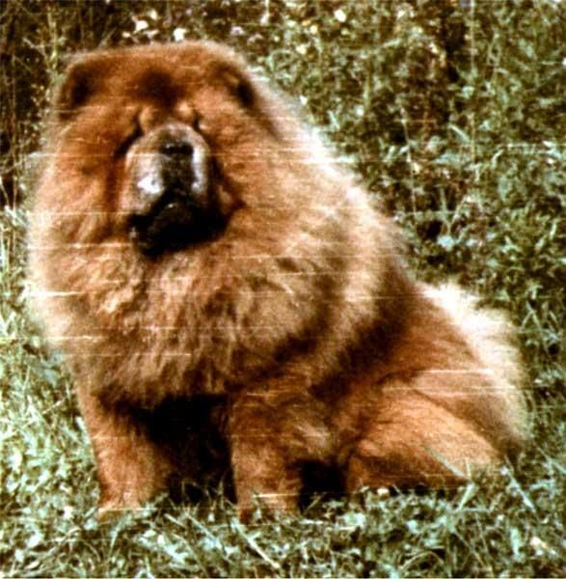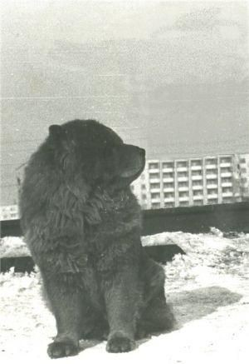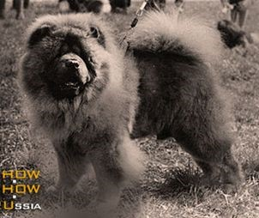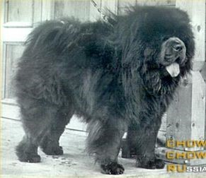
Igor vom Leimberg

Ilka vom Leimberg

Zeiss

Go Cej Silver Sedou

The littermates ​Igor and ​Ilka (​Qua-Zi-Wang E'man ex Tsu's Dolly vom Ponyhof) bred by Herbert Heise botah produced quality puppies. The most famous of them was a cinnamon male ​Zeiss (owner Koroleva).
​ A combination ​Zeizz to ​Go-Chun (owner Kupriyanova) produced a very famous male ​Go Cej Silver Sedou (Stepan) in 1987. He was also the first blue chow born in the USSR. Stepan was the first chow owned by A. A. Burykin (kennel ​Alkmena).
Stepan was a true chow chow - strong, compact, with the correct coat, good head and healthy extensions. All this together with a good exhibition temperament enabled him to win the title of Best of Breed in Czechoslovakia and Poland. He was the first Chow from the USSR to win at international exhibitions.
In the eighties the state then USSR issued a decree regarding public organisations. MGOLS was no longer to be the only center to organize and register obedience and companion dogs.

A new stage in the development of the breed
Also there were major political changes in The Soviet Union during those years. The Iron Curtain ceased to divide Europe. It became possible to attend international dog shows in a variety of countries and to meet chow chows bred in well known kennels. Everyone could now compare to the best of their ability the quality of Russian chow chows and the ones of the leading European breeders and outside Europe too.
These changes led to vast growing interest in the breed. The popularity of chow chow began to increase remarkably in Russia.
In the late eighties and early nineties Russian breeders indeed imported chow chows from Poland, Czechoslovakia, Germany, USA, Canada, The Netherlands and United Kingdom. Almost all of these imports carried bloodlines to well known British, American and Canadian breedings and has had a great influence to the development of the breed in Russia since.
Below you can see a detailed list of imports, whose contribution to chow chows in Russia has been remarkable. All of the ​Polish​ imports produced off spring of uniform type and quality:
- a red male​ Czefu Mumuru (​Polish Ch Mitsagi Ho-Sim ex Etola z Zamku Krzyzackiego), bred Mrs. Grazyna Madaj, owner Gordeev,
- a red male​ Castor Ben-Ken (​Polish Ch Mitsagi Ho-Sim ex Mercedes Ben- Ken), owner Khanke,
- a red male​ Fan-Tin Lorico (Ch Brit z Kouzlo Povltavy ex Ch Hanami Ann Czu)​ , owner V. Kudimova,
- a fawn male ​Chines z Niedzwiedziej Gawry (​Akim z Niedzwiedziej Gawry ex Betty Huzaruvka), owner M.Lenkova. He was the foundation of the kennel ​iz Kitayskogo Doma,
​ ➢ a red male​ Gulliver z Zamku Krzyzackiego (​Polish Ch Dong-Kajong van de Ganze Tapper ex Polish Ch Dalida v. Palma Del Rio) owner Mironova.
- a red female​ Betty z Mikolovskiej Jamny (​Polish Ch Barry Radynska Pecet CS ex Dunia z Muchowieckiej Zagrody) owner Intizarov,
- a red female​ Ofelia Negrus (​Diksi Dikson z Muchowieckiej Za-grody ex Chata Ann-Czu) owner Tits, kennel ​Titsan,
- a red female Honda Mar Iz And​ (Polish Ch Mitsagi Ho-Sim ex Messalina Ben-Ken​ ) bred by Andrzej Misiewicz, owner E.Krasheninnikova,kennel ​s Millionnogo Mosta​. Honda was one of the best producers in this kennel.

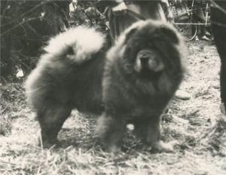  Czefu Mumuru | 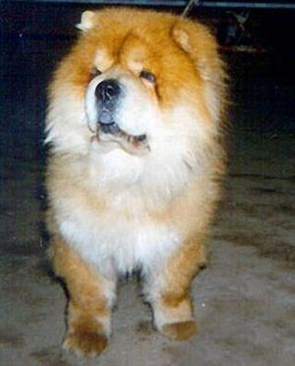  Castor Ben-Ken | 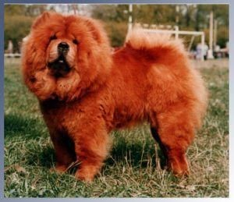  Fan-Tin Lorico | 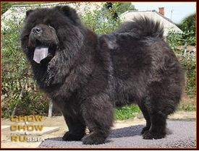  Gulliver z Zamku Krzyzackiego
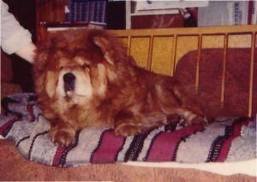  Ofelia Negrus | 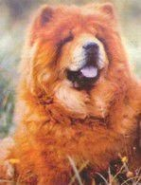  Honda Mar Iz And

​(40​)
The ​Hungarian​ addition was three males.:
- red ​Bakoni Orzo Jimbi (​Piciri Vili ex Kobuki Party Suzi), owner A.Baykov;
- black ​Kiralilaki Jack, owner A. Burkina;
- red ​Kiralilaki Idole (​Vou’ky De Berlaimont ex Kiralyki Dongo), owner R.Massar.
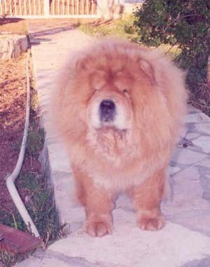  Bakoni Orzo Jimbi | 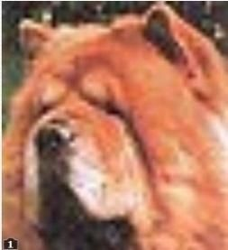  Kiralilaki Idole

Chow chow imports from ​Czechoslovakia​:
- a red male​ Ch. Athis Of Magnolia (​Mi-Pao's Canadian Ambassader eх Mi-Pao's Canadian Legacy) owner A.Burykin, kennel ​Alkmena​;
- a red male​ Ch Endy Perla Podkrkonosi (​Int, Cz Ch Ur-sus Of Magnolia ex Bubi Perla Podkrkonosi), bred by Adolf Semerak, ownedr Marina Saltykova, kennel ​Lucky Star;
- a red female​ Bela Perla Podkrkonosi (​Chung Zumako eх Kaiko Of Magnolia), owner A.G.Scherbakova, kennel ​Bel;
- a red female​ Ksantipa Dukat Severu (​Mi-Pao's Canadian Ambassader eх Edith Pa-Ko), owner A.Burykin, kennel ​Alkmena;
- a red female​ Erzika Sogun (​Heng Zumako ex Panella Pa-Ko), owner Zviagina;
- a red male​, Hagar Labska ​Cesta (​Mi-Pao's The Diplomat ex Fair Flight Labska Cesta), owner N.Demenev, kennel ​Airin;
- a red female​ Channella Labska Cesta (Mi-Pao's The Diplomat ex Aika Strimelicka Cesta), ownedr Pasin-Stankevich, kennel ​Vladlen;
- a red male​ Forbes Sogun (​Hanibal Pa-Ko ex HiFi of Magnolia), owner Steglikova;
- a red female​ Dulli Simako (female, red, ​Hanibal Pa-Ko x HiFi of Magnolia, owner Sokolova-Volkova). She was the foundation of kennel Makdena.
- a blue male​ Don Albrej (​Izmir Of Magnolia ex Falina Perla Chodska), owner V. Urajevskiy.
Kennel ​of Magnolia (owner Alain Kurova) deserves special attention. The imports to this kennel came from well known Canadian kennel ​Mi-Pao. Not only were these imports great producers but did also well in the show ring.
A red female Erzika Sogun​ (​Heng Sumako х ​Panella Pa-Ko) was the foundation of kennel ​Dziva (owner Zvyakina). She when mated to a red dog Mi-Pao's Red Robin (Can, US ch. Mi-Pao's Johnnie Walker​ х Miki's Rosemary​ ) produced a very famous male with many great wins ch. Urfin Dziva​ (owner E. Bogoslovskaya).
A mating between a black female ​Ena Dziva (​RusCh. Go Cej Silver Sedou х Erzika Sogun​ ) and a red male RusCh. Athis of Magnolia​ produced the first Russian World Winner, ​IntCh. Mafusail Insanta (br./owner A. Burykin, ​Alkmena).
Two famous followers to this successful bloodline were grandchildren of ch. Athis of Magnolia:
- Illarionov (owner Chikov), World Ch. & FinCh. in 1998, medalist of the 2000 World dog show in Milan of Italy, Ch. of Russia, Belarus, Estonia, Lithuania, Finland, Latvia, Ukraine, RKF, National Club Chow
- Drake Bonifacio (owner M.Vekovischeva), Ch. of Russia, Moldova, Ukraine, two times winner of National Club Chow
Ch. Endy Perla Podkrkonosi (​Intch. Czch. Ur-Sus of Magnolia х Bubi Perla Podkrkonosi​ ) bred by Adolf Semerak and owned by Marina Saltykova of kennel ​Lucky Star was Rus Ch. and gained many wins at major shows. This male was widely used at stud almost in the entire Russia and he produced quality off spring.
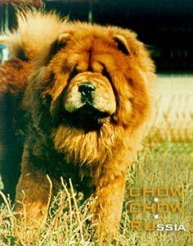 Ch Endy Perla  Podkrkonosi | 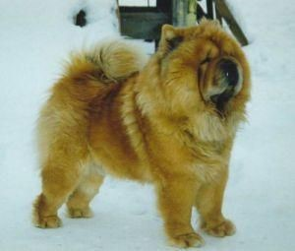  Mi-Pao's Red Robin | 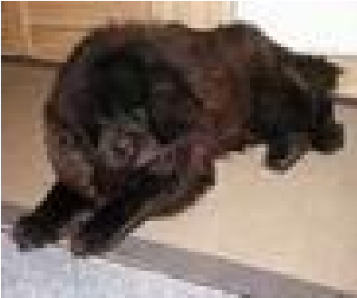  Ena Dziva | 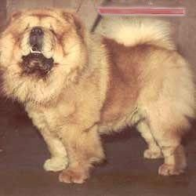  Athis Of Magnolia | 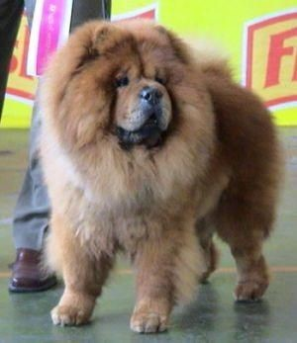  Illarionov
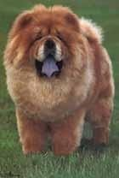  Mafusail Insanta | 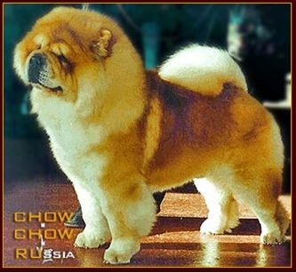  Drake Bonifacio | 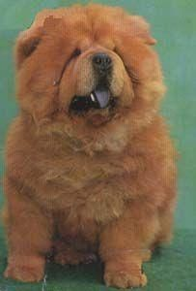Hagar Labska ​Cesta | 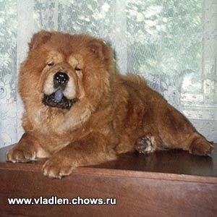 Channella Labska Cesta

Marina Saltykova (kennel ​Lucky Star) was a great breed enthusiast and also a judge for chow chow. She was in fact the first one to invite foreign breeder judges to shows in Russia.
As a result a well-known breeder judge Diana Phillips from United Kingdom was invited to judge "Moscow-95 in May". She also judged the breed at "Eurasia -96" in Moscow as well.
The next step was to invite another breeder judge Gillian Glaxton also from United Kingdom. It was the first united show on 7th December in 1996 arranged by The Russian Chow Chow Club, "Antallis" and association "Moloss-A". There were exhibited 171 chows at this show and in junior class red male chow chows were 34 dogs, in open class bitches red color were 24 females.
The first national chow chow specialty took place on 24 May in 1977. The judge was Jack Trick (Jowtrix) from United Kingdom. 157 chow chows were entered. The honourable judge commented the quality of the entry as follows: "80% of the chow chows were graded 'very good' and very few received 'excellent', but I feel that more careful breeding plans for the next five years will allow you to improve the quality."

Chow in the Russian regions
In late eighties and early nineties there were quite many chow chow breeders in other regions of Russia from Kaliningrad to Vladivostok, a city in the very eastern part of our country. One of the most successful areas for chow chow kennel even today is the Ural region.
A male ​Tseyz then from Leningrad (owner Koroleva) played a very important role for the breed in the Ural region in late eighties. A beautiful litter by him and ​Chan-Chun-Guli (owner N. P. Tasheva, kennel ​Derby Rosinta) produced many famous chow chows.
A male ​Don Albrej (​Izmir of Magnolia ex Falina Perla Chodska) owner V. Urazhevsky was imported from then Czechoslovakia. His progeny consisted of many interesting black and blue chows. One of them was the famous blue male ​Blues Legorta (​Don Albrej ex Kwei Si Enz Sival, owner N. P. Tasheva, kennel ​Derby Rosinta). He sired puppies also in other regions of the country.
Diana Boticke Udoli (​Dick Malajsky Tygr ex Betty Hvezda Svihov), ​Gamon Majamy and ​Gressi Pa-Ko were also imported from Czechoslovakia in the nineties.
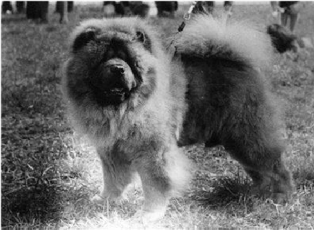  Tseyz | 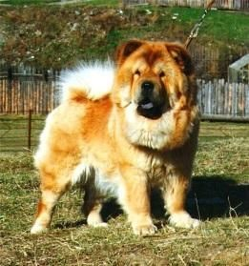  Diana Boticke Udoli | 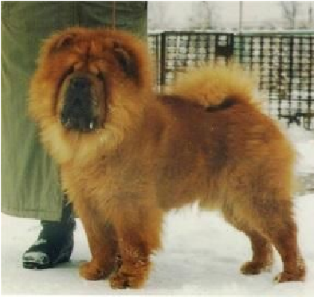  Gamon Majamy | 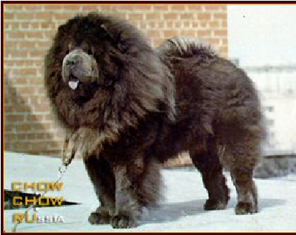  Blues Legorta | 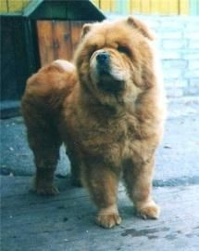  Grеssi Pa-Ko

Chow chow imports from East Germany and also used for breeding in the North West region of Russia:
- a black male ​Damon v. Castell De Blohm (​Black Sambo v. Tiko-Ling ex Holly z Zamku Krzyzackiego), owner Shestakova.
- a red female ​Sian-Fu Onsha (​Sian-Fu Di-Wang ex Sian-Fu I-Lu), owner L. Shevchenko, kennel Kama Lakshmi. She was imported in 1985 and had a great influence to the development of chow chows in Leningrad.
- a red male ​Arthos v. Haus Wollenberg (​Sian-Fu Bu-Wang ex Jana v. Hinterm Walde), owner Shestakova,
- a red male ​Kliff v. Grunen Lauch (​U-Kwong v. Weidatal ex Ben-Chia v. Haingarten), owner Shestakova,
- a red female ​Bjanka v. Kaizers Chow-Paradise (​Hei Yu-Tzu Hey Ching-Ko ex Akulina v. Kaizers Chow Paradise), owner N. Kostygova, ➢ a red male ​De-Ching Wong v. Boccasana (​Sian-Fu Bu-Wang ex Bambi Comtess v. Boccasana), owner Lavetskaya.
I would like to mention two brothers by an import from Germany. The sons ​by El-Kwong von der Kleinen Pfirsichblute: ➢ a red male ​Sotschi von der Kleinen Pfirsichblute (dam ​En-Yu-Tha v. Salome), breeder H. Jansch, owner O. Davidyuk, ➢ a fawn male ​Nirong v. Man-da-rin (dam ​Sian-Fu Kua-Li), owner N. Zenkovich.
A fawn male ​O'Shimas Ozzi Bear (​Amitos Oliver x O'Shimas Taff Staff), owner Knyazeva, was a Swedish addition.
Sotschi von der Kleinen Pfirsichblute sired progeny not only in Moscow but in the Urals too. A red son by him ​Nukk Khryu S Millionnogo Mosta, owner A. Minkov, was best of breed at the first All-Russian chow specialty. The judge was Gillian Glaxton from The United Kingdom. The dam of this male was a Polish import ​Honda Mar Iz And. Her breeder Andrzej Misiewicz and owner E. Krasheninnikova, prefix ​S Millionnogo Mosta.
A breeding between two Czeckoslovakian imports ​Sotschi von der Kleinen Pfirsichblute and ​Askia vom Raci Tune, produced a beautiful litter in Sverdlovsk. The pick of this litter ​Shi Ling was crowned as the first champion of Russia born in the Ural region. She was also the foundation bitch of Kennel ​Ruby Asterhaus, owner T. Scherbakova.
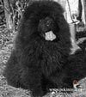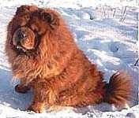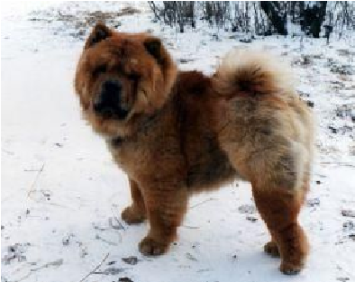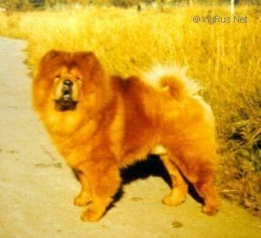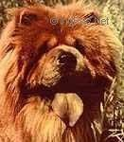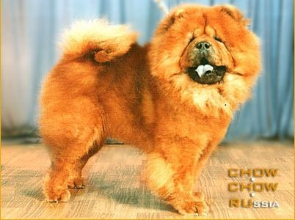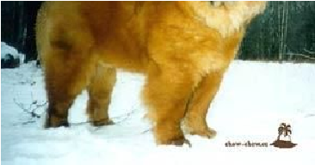
Damon vom Castell

De Blohm

Sian-Fu Onsha

O’Shimas Ozzi Bear

Nukk Khryu S

Millionnogo Mosta

Sotschi von der

Kleinen Pfirsichblute

Nirong v.

Man-da-rin

Shi Ling

Chow chows from the UK
​Males from the UK. - ​Greatmoor Satan Son (​Tanlap Satan ex ​Greatmoor Fudge) bred by Mrs. G.I. Shaw and owned by Russo, was imported from Great Britain in the beginning of eighties. Descendants by him can be found both in Russia and Ukraine even today.
Soon after a red male ​Smarty (​Lechan Tokyo Joe of Sakura ex ​Antina Leontina) arrived Russia. Owner Zaklinskaya.
In 1994 there were three males in Russia bred by Anita Westlake in her famous ​Baytor kennel.
- a black male ​Baytor Black Boris (​Blue Drummerboy Of Baytor ex Baytor Excuse Me I'm Chinese), owner L.Ilina, kennel ​Jae Chau, Saint-Petersburg),
- a red male​ Baytor Battery Not In-cluded (​Zhenshi Sa'Valvat Truffle of Baytor ex Baytor Crimson Moon), owner N.Tasheva, kennel ​Derbi Rosinta, Yekaterinburg,
- a red male​ Baytor Balakirev (​Zhenshi Sa'Valvat Truffle of Baytor ex Baytor Tiger's Tail), owner U. Fedorenko, kennel ​Dgulideil, Irkutsk.
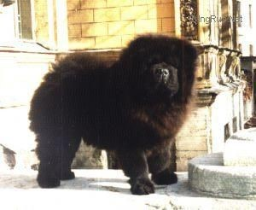  Baytor Black Boris | 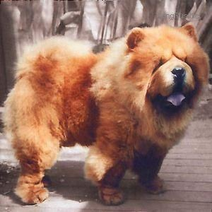  Baytor Battery Not In-cluded | 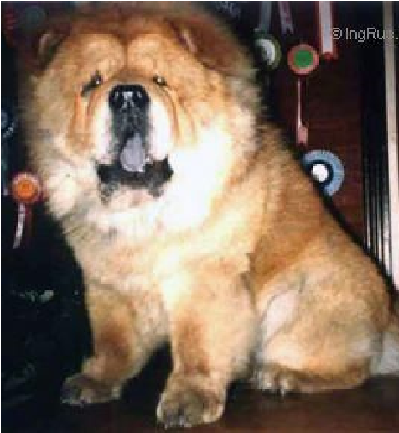  Baytor Balakirew

The most well known sons of ​Rus Ch Baytor Black Boris were Ch. of Russia, Estonia, Belarus, Finland, Ch. of breed club​ K’Call Me Black (owner L.N. Shevchenko, kennel ​Kama Lakshmi in Saint Peterburg), Rus Ch​ Dgulideil Original (owner L. Ilina, kennel ​Jae Chau in Saint Peterburg), Ch. of Russia and Estonia​ Leon (owner N. Sokolova, kennel ​Kya Van Li in Saint Peterburg).
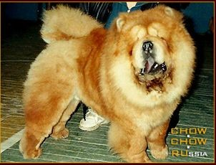  Napoleon De Berlaimont | 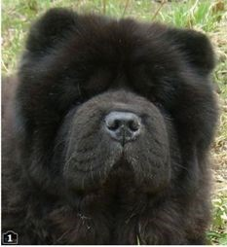  Dgulideil Original | 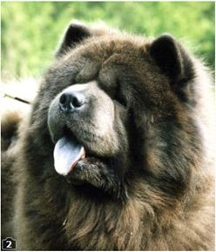  Leon | 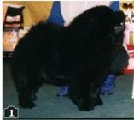  K'Call Me Black
In addition to above, several other males were brought in from the UK at the end of the 1990s:
- a blue male​ Baytor Blue Romeo ​ (Blue Drummer Boy of Baytor ex Baytor Lady Leonora) owned N.Tasheva, kennel ​Derbi Rosinta, Yekaterinburg,
- a red male​ Kyong Kagney At Fullforge (​Ch. Bosleigh Bee-Jay At Korina ex Kyong Kari-B-Ann) owned N.Tasheva, kennel ​Derbi Rosinta, Yekaterinburg,
- a red male​ Travennen Jazz Man (Zhenshi Sa'Valvat Truffle of Baytor ex Baytor Moon Over China of Trevennen​ ) owned I.Arsenteva, kennel Tsvetok El’fov Moscow;
- a red female Ch., Int Ch. Trevennen Russett of Baytor​ (​Zhenshi Sa'Valvat Truffle of Baytor ex Baytor Flower in the Rain of Trevennen), bred. S.A. Stephens, owned L. Yusypova, kennel ​Zolotaya Orkhideya, Yekaterinburg,
- a red male Vice-European Champion 1999 Rus Ch ​Towmena Cutty Sark (​Byhorn Jute ex Towmena Stella Artois), bred R.P. Oldham, owned L. Yusypova, kennel ​Zolotaya Orkhideya, Yekaterinburg,
- a red male​ European Champion​ 2001, Rus Ch​ Dawnanda Distinguished Don (​Carmalde Can Can Charlie with Dawnanda x Dawnanda
Onuska), bred. D. & M. Butterworth, owned L. Yusypova, kennel ​Zolotaya Orkhideya, Yekaterinburg,
- a red male Russia, Belarus, Georgia Ch. Byhorn Red Kale​ (Byhorn Jute ex Byhorn Summer-Thyme)​ , bred. P. Hornby, owned A.Burykin kennel
Alkmena.
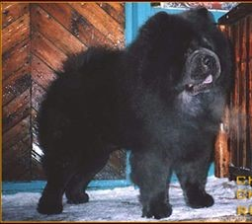  Baytor Blue Romeo | 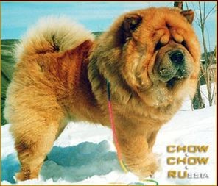  Kyong Kagney At Fullforge | 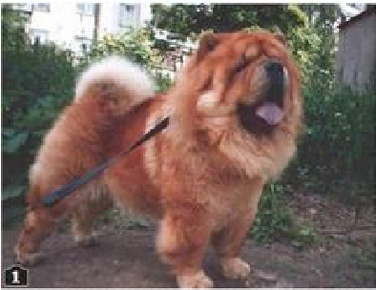  Travennen Jazz Man | 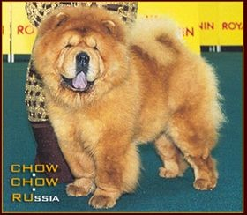 Ch., Int Ch.  Trevennen Russett of Baytor
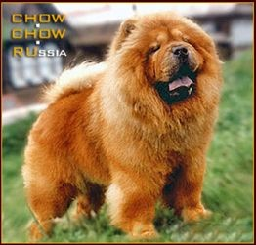  Towmena Cutty Sark | 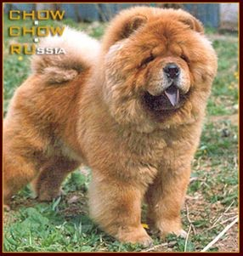 Dawnanda  Distinguished Don | 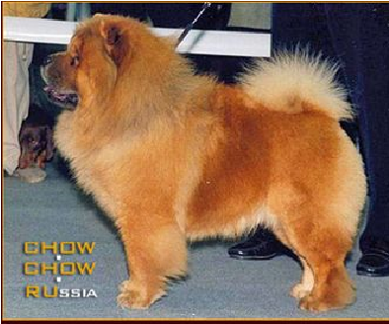  Byhorn Red Kale

Chow chows from the Netherlands
There were several imports from the Netherlands. They made a very visible and significant contribution to the development of the breed in Russia. These males sired quality puppies for kennel ​Medis Dream (owner M. Dronova) in Moscow region and kennel ​Hurakan Maribet (previously ​Lucky Star, owner M. Saltykova).
The two Dutch imports: A red male Eur Winner, Ch. of Russia and Ukraine ​Ambassador v.h. Venne-Dorp (​Dusty Dancer of the China's Joy ex Lizelotte v.h. Venne-Dorp) owned by M. Dronova.
A red male ​Dream Chaser of the Royal Club (​Cross B's Mr Wun-Der-Ful ex Good luck Charm of the Royal Club) bred by K. & B. Buurman and owned by M. Saltykova. He sired 12 champions.
Ambassador v.h. Venne-Dorp sired off spring square in outline, strong bone, typical angulation and movement. Heads were beautiful and clean cut.
Noteworthy descendants of ​Ch. Ambassador v.h.Venne-Dorp:
- Rus Ch Barney,
- Rus Ch Medis Dream Caliph,
- Rus Ch Medis Dream Eksellent, ➢ Rus Ch Medis Dream Ambassador Junior, ➢ Rus Ch Medis Dream Utah.
Rus Ch ​Master of Illusion of the Royal Club (​Cross B's mr Wun-Der-Ful ex Cover Story of the Royal Club) owned by Zhavrit was yet another Dutch import to the Far East part of Russia
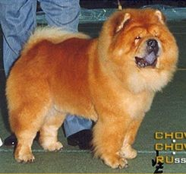 Ambassador  v.h.Venne-Dorp | 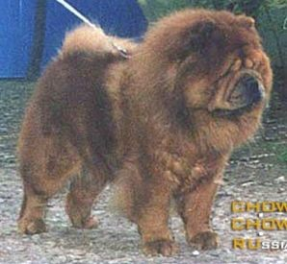 Dream Chaser of the  Royal Club | 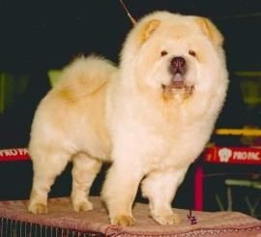 Medis Dream  Ambassador Junior | 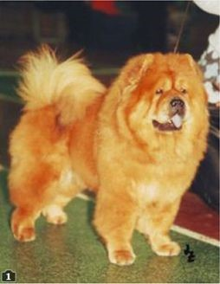  Medis Dream Utah | 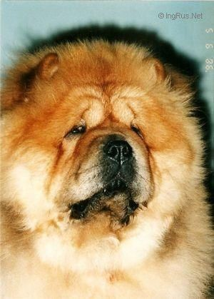 Master of Illusion of the Royal Club

Chow chows from Sweden
A red male Rus Ch ​O'Shimas Ozzy Bear (​Amito's Oliver ex O'Shimas Taff Staff) was bred by Vivi-Ann Wallgren and owned by S. Knyazeva, kennel Almond Flower arrived to Russia in early 1990s.
A cream male Rus Ch Chowhill's Who Wants To Know​ (Jo-Fu-S Cream Marino ex Chowhill's Step Into The Light​ ) was bred by Monika Karlsson and owned by J. Kitavtseva. He entered Russia in late 1990s. This male sired a well known cream female Rus Ch Kapriz Zheni Ju-Lya-Lya​ owned by E. Kaptsov, kennel ​Kapriz Zheni.
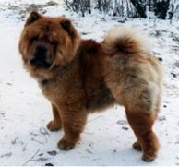  O'Shimas Ozzy Bear | 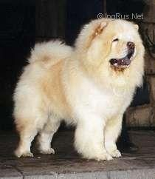  Chowhill's Who  Wants To Know | 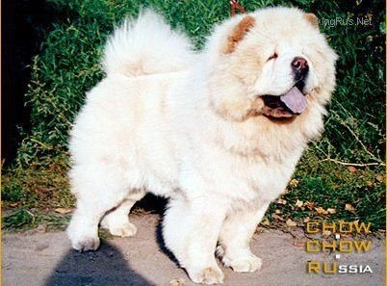  Kapriz Zheni Ju-Lya-Lya

Chow Chows from France
- a blue male​ Lanji Du Ban Caou (Vanqiang De Syr Daria ex Ho-Chi-Minh of Blue Baron)​ , owned L. Yusypova, kennel Zolotaya Orkhideya,​ Yekaterinburg,
- a red male​ Napoleon De Berlaimont (​Oes-Ming Chy-Nees ex Ellmau Kwei-Jang), owned Lenkova, kennel ​Iz Kitayskogo Doma, Moscow
- a red male Rus Ch, Interchampion ​Little-Buddha Du Lee-Dou Des Thitounes (​Harley de la Palestriere x Happy Day of Blue Baron), breeder Eliane Bernard, owner L. Yusypova, kennel ​Zolotaya Orkhideya, Yekaterinburg.
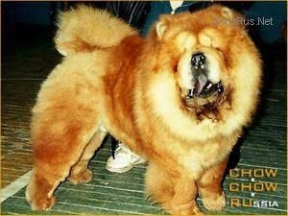  Napoleon De Berlaimont | 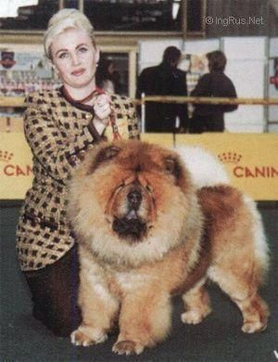 Little-Buddha Du Lee-Dou Des Thitounes

Chow Chows from USA
Dogs of the famous American and Canadian Chow kennels were beginning to appear in Russia in the middle nineties.
Irok's Bandit (​Les-Mar's Token To Irock x ​Ch Nawrocki's Misty Ling), owner V.Kudinova kennel ​Is Russkoy Skazki, Moscow was brought from the
United States
Irok's Bandit became the Champion of Russia. He proved as an excellent producer. He was an excellent producer. Many famous Russian champions were sired by him:
- Junior World Champion ​Monty Makdena (kennel ​Makdena, owners Sokolov and Volkov, Moscow)
- Rus Ch ​Charm Mon Cher (kennel ​Avgit, owner O.Ivanova, Moscow)
- Rus Ch ​Ayra (kennel Russkaya Zabava, owner T.Kuznetsova, Moscow).
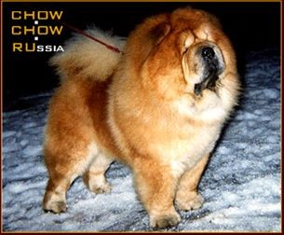  Irok's Bandit | 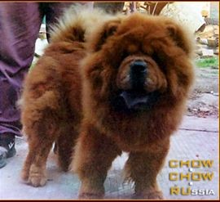  Монти Макдена | 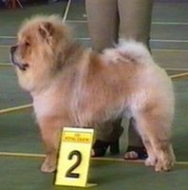  Charm Mon Cher | 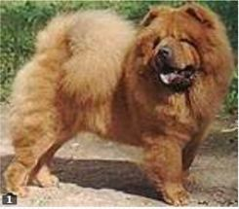  Ayra
A fawn male from USA ​Big Mack Attack (​Lan-Chu's Mad Max of Medley ex​ ​Biddle's Sweet Pickles, owner I.Arhipov, Moscow) was a great asset for kennel ​Avgit (owner O.Ivanova in Moscow). Among his descendants are found well known males: Russia, Ukraine, Lithuania, Estonia, Moldova and Belarus Champion ​Chatkall Blue Is My Love, a cinnamon male Russia, Ukraine, Belarus, Lithuania and Latvia Champion Avgit Dunfan Sho​ , Rus Ch and the National Snow Country Club ​Lord Sherman (owner G.Yakimenko).
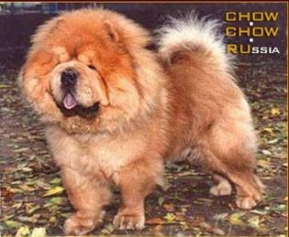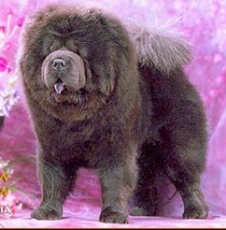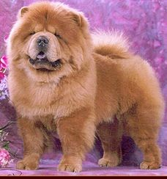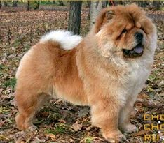

Big Mack Attack

Chatkall Blue Is My

Love

Avgit Dunfan Sho

Lord Sherman

Moscow kennel ​Vladlen (owners V.Pasin and E.Stankevich) acquired a bloodline from the US - it was the male American Ch., then Russian and Finnish Ch ​War-Rah's Masterpiece and his daughter ​Masterpiece Liquid Assets and grandson ​Masterpiece All American.
Ch. War-Rah's Masterpiece - sired beautiful descendants both in USA and Russia. Among his well known descendants born in Russia: a red female Russia USA, Ukraine, Estonia, Lithuania and Moldova Champion, ​Nyusha Vladlen, a red male American Ch Vladlen Fyodor​ , a red male Russian, Ukraine and Moldova Champion ​Vladlen Yankees.
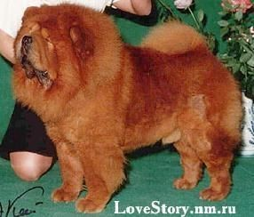  War-Rah's  Masterpiece | 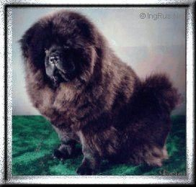 Masterpiece Liquid Assets | 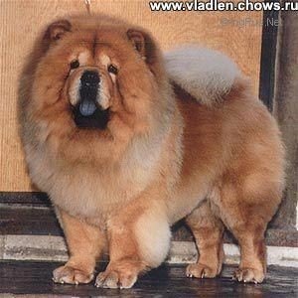 Masterpiece All American | 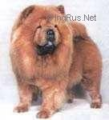  Nyusha Vladlen | 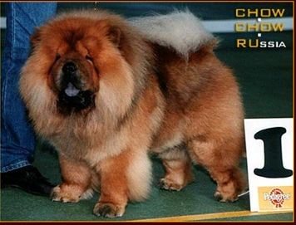  Vladlen Yankees
A red male ​Ricksha Desperado (​Artpho's Bulletin Bo-ret x ​Riksha's Razzle Dazzle) and a black male ​Pondview's Black Russian (​Triger Cagney x Gilmar's National Secret) owned Tyagunova, kennel​ Prekrasniy Tees were brought from the United States in 1995. - These males played a significant role in the development of the breed in the south of Russia (Rostov-on-Don).
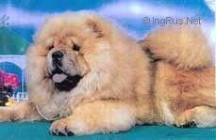  Ricksha Desperado | 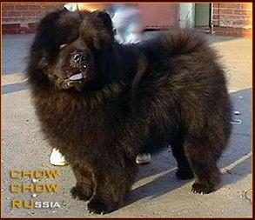 Pondview's Black Russian

Chow Chows from Canada
Chows imported from Minnie and Paul Odenkirchen's ​Mi-Pao kennel in Canada have had really great influence on the development of our breed in Russia. Well known kennels like ​Alkmena (A. Burykin) and ​Bis Lac (E. Gavryushina and N. Feofanova) based their breeding lines on ​Mi-Pao imports.
The first Canadian import was a fawn male ​Oban's Stir-ling (​Oban's Bonnie Prince Charly x Oban's Lady Di) bred by O. Newton and owned by E. Gavryushina. This male proved his value to kennel ​Bis Lac. He sired easily recognizable quality offspring mostly in red and fawn colours. The most well known were Rus Ch. ​Bis Lac Rover owned by A. Elyutina and Rus Ch. ​Bis Lac Bandera owned by E. Gavryushina.
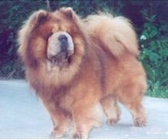  Oban's Stir-ling | 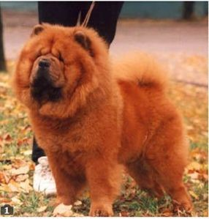  Bis Lac Rover | 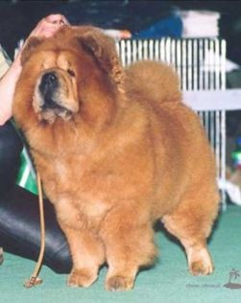  Bis Lac Bandera
E. Gavryushina also imported two chows from kennel ​Mi-Pao. A cream male Ch. ​Mi-Pao's Devon Cream (​Can.Ch. Mi-Pao's Black Phantom ex Mi-Tu's cream Puff) and a red female Ch. ​Mi-Pao's Red Serenity (Can. US Ch. Mi-Pao's Johnnie Walker ex Miki's Rosemary​ ). These two together with Oban's Stirling became the basis for her kennel ​Bis Lac.
Ch. Mi-Pao's Devon Cream and ​Ch. Mi-Pao's Red Serenity produced a star litter with the three first champions for kennel ​ ​Bis Lac:
a red female Rus Ch, Ch. National club of breed ​ Bis Lac Dessa (owner A.Elyutina), she was a mother of JWW-1998 ​Bis Lac Absolute; ➢ a red female Rus Ch, Belarus, Ukraine, Lithuania, Ch National club​ Bis Lac Jennifer (owner I.Abramova); ➢ a red female Rus Ch​ Bis Lac Daria (owner N.Feofanova); ➢ a red male Rus Ch​ Bis Lac Diplomat (owner T. Usova).
Ch. ​Mi-Pao's Devon Cream produced quality off spring with females of different type and quality. Such as the three remarkable males:
- a red male​ Russia, Belarus and Ukraine Ch.​,winner of special chow chow show in​ Bis Lac Monarh (owners E.Gavryushina and I.Abramova), ➢ a cream male Russia and Belarus Ch. ​Bis Lac Edgar (owner L. Zavyalova), ➢ a cream male Rus Ch​ Bis Lac Yago (owner N.Karbovich).
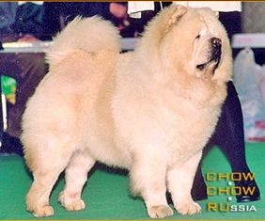 Ch. Mi-Pao's Devon Cream | 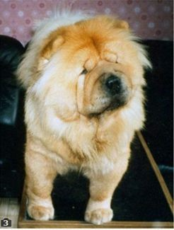 Mi-Pao's Red Serenity | 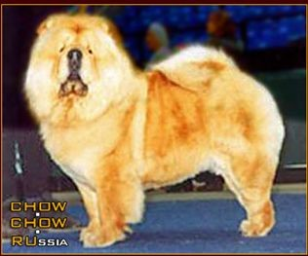  Bis Lac Dessa | 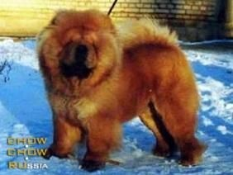  Bis Lac Absolute | 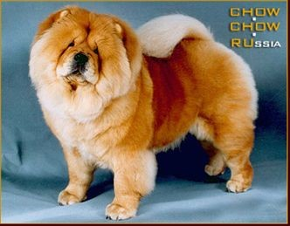  Bis Lac Jennifer
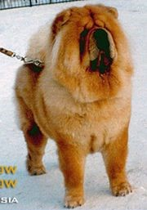  Bis Lac Daria | 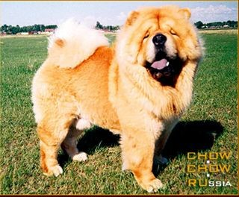  Bis Lac Diplomat | 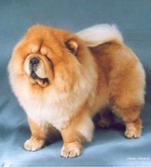  Bis Lac Monarh | 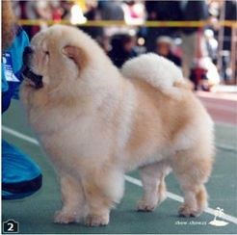  Bis Lac Edgar | 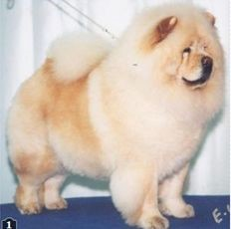  Bis Lac Yago
In 1999 two new imports from Canada arrived to kennel ​Bis Lac. A cream male ​Mi-Pao's Cream Applause and a red ​female Mi-Pao's Canadian Missy.
Ch. of Russia and Belarus​ Mi-Pao's Cream Applause sired 7 champions. Among them:
- a cream female Ch. of Russia, Estonia, Ukraine, Lithuania, Belarus of ​Bis Lac Izyumi (owner A.Elyutina);
- a cream female Ukraine and Moldova Ch. ​Bis Lac Love Is (owner O. Piskareva); a red male Rus Ch​ Bis Lac Nugget Gold (owner E. Antonova); a red male​ Belarus Ch. ​Bis Lac Magic Show (owner A.Marchenko).
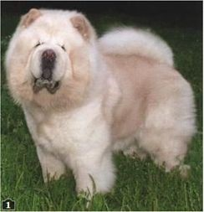 Mi-Pao's Cream Applause | 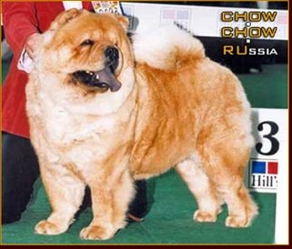 Mi-Pao's Canadian  Missy | 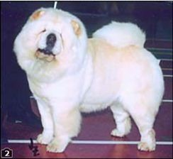  Бис Лак Изуми | 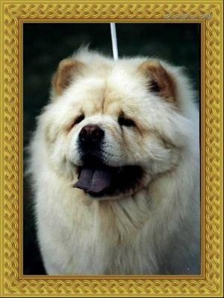  Bis Lac Love Is
Kennel ​Alkmena owned the following ​Mi-Pao chow chows:
- a red male ​Mi-Pao's Red Robin (Ch. of Canada​, America​ Mi-Pao's Johnnie Walker eх Miki's Rosemary), ➢ a red female ​Mi-Pao's Flight of Fancy (​Mi-Pao's Tobias x Mi-Pao's Pitchers Raigens Cream); ➢ a black male ​Mi-Pao's Midnight Cruising (​Mi-Pao's Black Phantom х Mi-Pao's Deidra).
This trio produced many beautiful Russian champions. ​Mi-Pao's Midnight Cruising sired the red female ​Alkmena Kaina with an impressive list of titles: Junior World Winner, European Winner, Russian Ch., Belarus Ch., Danish Ch., International Ch.. her mother the red female Alkmena Dream​
Bonifaci.
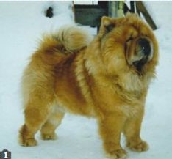  Mi-Pao's Red Robin | 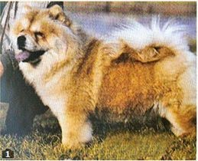 Mi-Pao's Flight of Fancy | 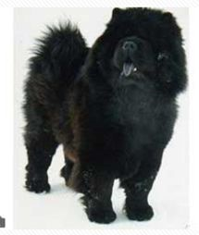 Mi-Pao's Midnight Cruising | 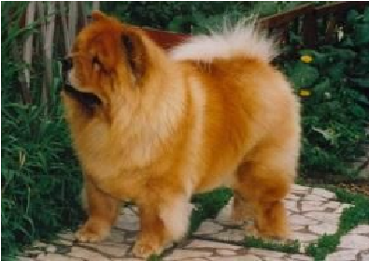  Alkmena Kaina | 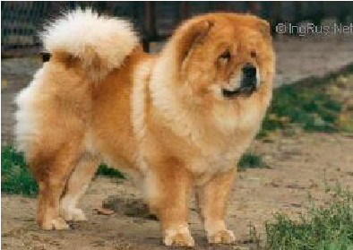  Alkmena Dream Bonifaci
If we analyse pedigrees of Russian chow chows, it is easy to see that there are imports from many European countries, United States and Canada in 1980s and 1990s. The famous and well known United Kingdom kennels were represented in these imports by lines from ​Ukwong, Mong-Fu, Weircroft, Tanlap, Mitsagi, Hanoi, Baytor.

Chow chow in Russia at the beginning of 21st century
The smooth chow chow variety was quite unknown and rare in Russia in 20th century. Not one kennel had shown interest for smooth coats in their breeding programs. The first kennel to focus on the smooth variety too began its work in 1999. Today we all know Marina Akulova and her kennel "Love Story" in Moscow. The Russian Kennel Club, RKF, registered the prefix as ​Lav Stori.
This kennel was the first to import smooth chows from Europe and United States. A red male ​Si Huang-Ti Velvet Prince (​Marko v.h. Venne-Dorp ex Si-Huang Ti Velvet Kate) arrived in Moscow from Hungary. A red male ​Lo-Re Pepperland Troubadour (​Lo-Re Pepperland Valentino ex Lo-Re Pepperland Martina) was imported from the famous American lines and breeder​ in 2005.
These two males sired many puppies with females of different lines and it has been easy to see their strong influence in overall quality and in particular heads. The story continues by their off spring being actively used in many kennels and not only in Russia.

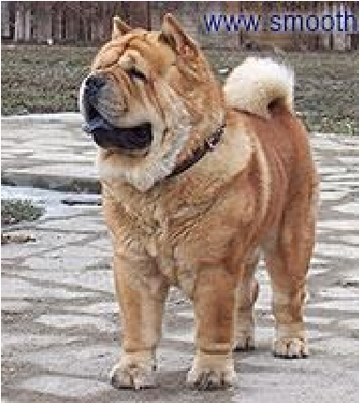  Si Huang-Ti  Velvet-Princt and his descendants | 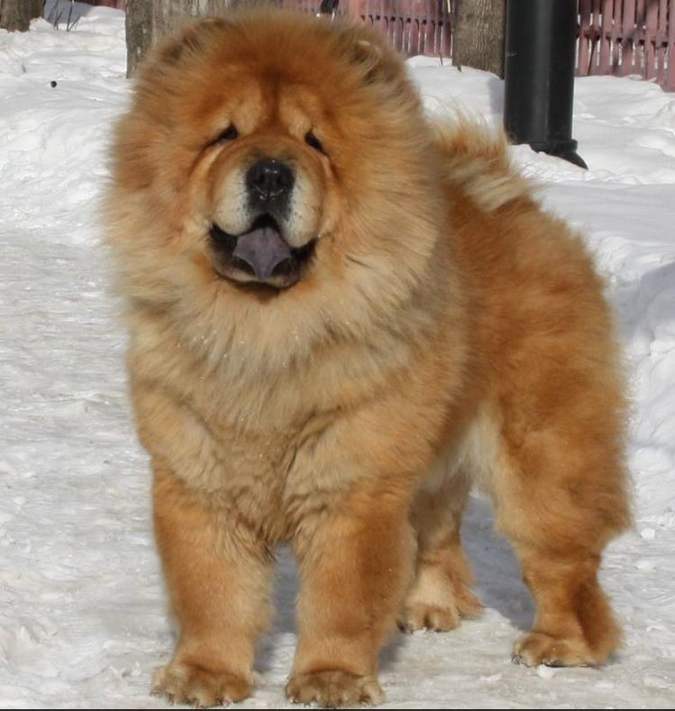  Anabel Koroleva Chardasha  (​dam​ Irmhof Lir  Zhizel),  owner A.Sukhanova | 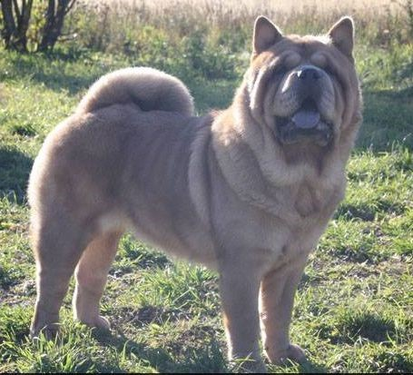  Col’veyg S Sergieva  Posada  (dam ​Oktafiya  Fayeru S Sergieva  Posada)​, owner  O.Alexsandrova | 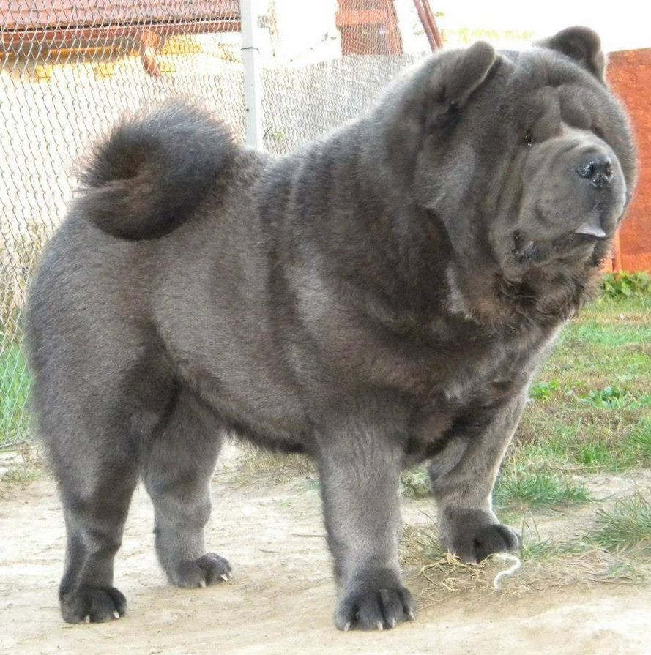  Karma In Blue for Si Huang- Ti  (dam ​Avgit Viv’en Kobal’t), owner  Angela Rabai Hungary | 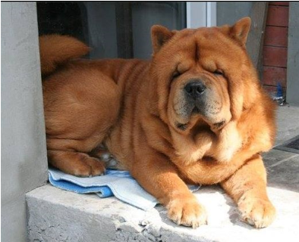  Nayk ​ S Sergieva  Posada  (dam ​Gasha S  Sergieva Posada)
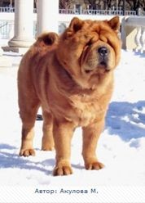  Lo-Re’ Pepperland  Troubadour and his descendants | 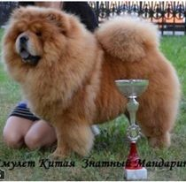  Amulet Kitaya  Znatnii Mandarin  (dam ​Elegant Mirekl Yanessa), owner G. D’yakova | 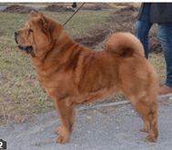  Ti Ai Shi Plush s  Sergieva Posada  (dam ​Oktaviya  Fayeri S Sergieva  Posada Krasniy)​, owner  O.Alexsandrova | 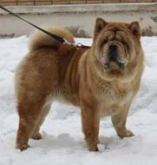  Lav Stori Imagien Smooth Perfect  (dam​ Latibur I Am Proud to be Smooth), owner N.  Kapitanova | 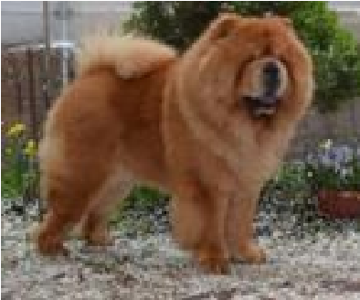  Osenniy Potseluy  Faier Stalker  (dam ​Lunnaya  Sonata Fair Stalker), owner T. Zavarova
A cream male ​Mi-Pao's Canadian Surprise (​Mi-Pao's Cream Nugget ex Mi-Pao's cream Crystal) was yet another Canadian import. This time to N. Mihaylova of kennel ​Ot Russkogo Couturier in the city Velikiy Novgorod in 2010.
This cream male has been widely used and both his looks and style are easily recognizable. He has off spring in many Russian kennels and in fact all over our globe.
I would like to mention one of the females ​Vatrushka Ot Russgogo Couturier (​Mi-Pao's Canadian Surprise ex Love Stori Imegien Smooth Perfect) owned by Wendy Absalom in United Kingdom. She has done quite well at shows and received a lifetime qualification to Crufts.
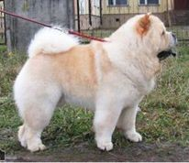  Mi-Pao"s Canadian  Surprise and his descendants | 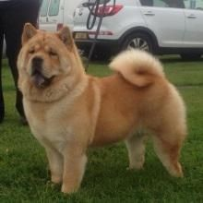  Vatrushka Ot Russgogo Couturier, | 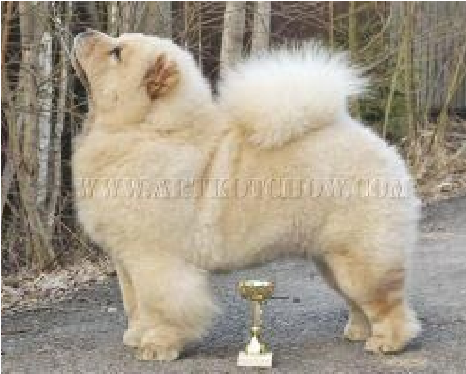  Alliluya Ot Russkogo Couturier | 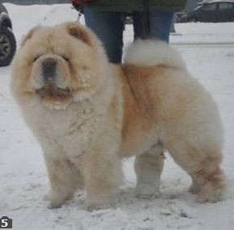 ​Chi  Royli ​Ot Russkogo  Couturier  (dam ​Iris Ot Russkogo Couturier), owned
 | (dam ​Love Stori Imegien Smooth Perfect), owner  Wendy Absalom, the UK | (dam ​Iris Ot Russkogo Couturier), owner N.  Voytsekhovich | I.Belyakova

A red male ​Baby Boon Dei Leoni Imperiali (Quiet Please Dei Leoni Imperiali ex Stagebos Queen of Spades​ ) owned by E. Pokinchereda of kennel Ch-Dalen was imported from Italy in 2009.
Anna Burkina of kennel ​Latibur in Moscow has imported the following chow chows:
a red male ​Elected Tauras Cunami (​Rich Raujan Cunami ex Velvet Malibu of Cunami Lietuvos Liutas) from kennel ​Cunami in Lithuania​ in 2006;
- a red male Paramount Only You for Latibur​ (Paramount Hi-Tone ex In The Arms of An Angel​ ) from USA in 2011;​
- a red male ​Incipit Universal de Latibur (​Paramount American Outlaw ex Incipit Just Starry) from the Norwegian kennel in 2013.
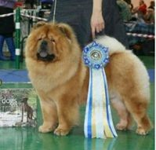  Baby Boom Dei  Leoni Imperiali | 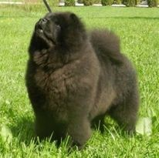  Look at Me Dei  Leoni Imperiali | 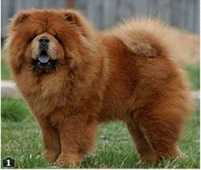  Elected Tauras  Cunami | 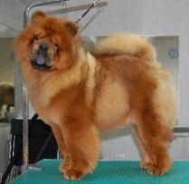  Paramount only you for Latiburg | 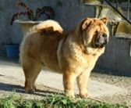  Incipit Universal de Latibur

Chow breeders in Ural region imported many chow chows from the American kennel ​Mei-Ling:
G. Yakimenko's ​Zhemchuzhina Dinastii kennel acquired ​Mei-Ling's The Great Merlin, Mei-Ling's Man of Fashion, Mei-Ling's Give a Kiss.​.
T. Schherbakova's ​Rubin Asterhaus kennel imported a cream male ​Beso Me Mucho Chow Troyka from Germany. In its pedigree appear only
Mei-Ling breedings

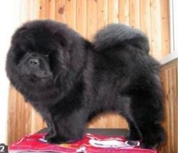  Mei-Ling The  Great Merlin | 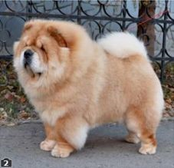  Mei-Ling Man of Fashion | 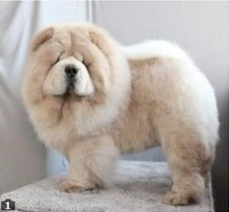  Mei-Ling Give Me a Kiss | 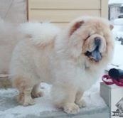  Beso Me Mucho Chow Troyka

I would like to mention one more occasion from the beginning of 21st century. M. Vekovisheva (​Bon Triumph) borrowed for breeding purposes Towsushet's Mr. President (​Rio's Celebrates Good Tymes With Towsushets ex Shiyue A Star Is Born With Towsushet) from United Kingdom. He bred on and stamped his type and his descendants are to be found in many lines of breeding today.
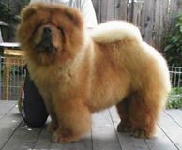  Towsushet’s Mr  President and his descendants | 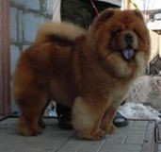  Bon Triumph  Armany (dam ​Bon Triumph Alisa), | 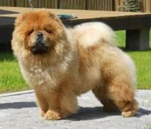  Bon Triumph  Yuritmix  (dam​ Bon Triumph Zefirka), owner  S.Erinova, Belarus | 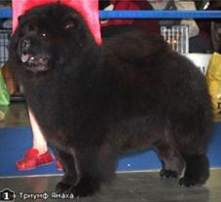  Bon Triumph  Yamaha (dam ​Bon  Triumph Daniella  Princess Night),
 | owner I.  Svetlichnaya |  | owner,  M.Vekovischeva

A black male ​A&I of The Island Spanish Gypsy (Mei-LIng's Buzz Liteyear ex A&I of The Island Dream Come True) was imported from Spain by Zh. Smirnova, kennel ​Zhasmir Collection.
A red male ​Akakuro Garnet Flame (​Akakuro Aidan ex Alycia of The China's Joy for Akakuro) was imported from United Kingdom by M. Rakuta, kennel ​Ot Sibirskogo Medvedya.
Kennel ​Simauta Dess, A. Elyutina, imported a female ​Lechan Melisandre (​Simauta Dess Rizhii Shum for Hiswin ex Lechan Christmas Eve).
From 2003 to 2007 new imports from Denmark to Russia:
- a black male,​ Orinell's Embrace Me (​Pei Fang Norwegian Cream x Orinell’s Amy The Black Princes), bred by Mette & Poul Erik Maj, owner
T.Petrova;
- a red male,​ Piuk Chow Royal Danish Prince Russ (​Pei Fang Norwegian Cream х Piuk Chow Precious Miss Independent, bred by Michael Lunau, owner M.Dronova;
- a black female, ​Piuk Chow Rose Princess of Denmark (​Pei Fang Norwegian Cream х Piuk Chow Precious Miss Independent) bred by Michael Lunau, owner A.Elyutina.
- a black female, Rus CH, FinCH, Finnish Junior Winner'07, 2xFinnish Club's Winner'08-09, ​Orinell’s Dream Delight (Pei Fang Midnight Massarati Man ex Orinell’s Amy The Black Princes),​ bred Mette & Poul Erik Maj, owner A.Elyutina.​
Their descendants are successfully used in breeding now.
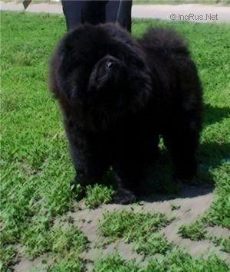  Orinell's Embrace Me | 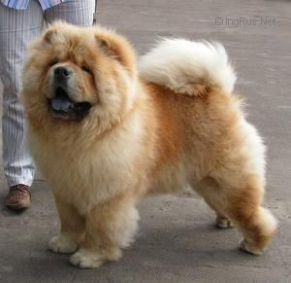  Piuk Chow Royal Danish Prince Russ | 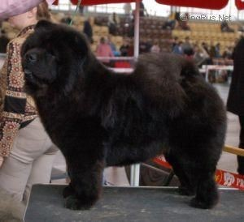  Piuk Chow Rose Princess of Denmark | 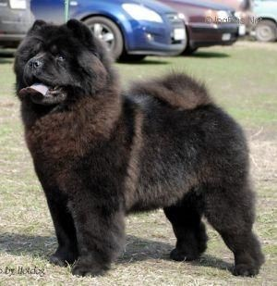  Orinell’s Dream Delight

There are most certainly other imports to Russia in early 21st century that I may not know of. At present Russian chow chow breeders export frequently, while the number of imports are decreasing. The quality of our chows has been recognized world wide.
I believe the many chow chow imports over time to Russia have not all been of top quality. However, used in clever breedings they due to excellent pedigrees have helped to improve the quality of Russian bred chow chows.
Of course breeding does not result in a success story by every litter. Carefully planned combinations do not always turn out as expected. However, we can be proud of the knowledge and quality the Russian breeders have gained. We wish them continued success! The story continues!
I would like to finish this article with the words from "History of the Chow in Russia": "We have to understand - we [Russian] do not create this wonderful breed, we only got it ready-made, in all its glory. And our task - not to hurt, but to try to do everything possible to improve it."

​Chow Chow Russian breeding - the winners of the world's largest exhibitions

Title | Dog’s name | Pedigree | Photo
World Winner - 1996 | Red male  MAFUSAIL  INSANTA | ATHIS OF MAGNOLIA ex  ENA DZHIVA,  breeder N.Nikitenko,  owner A.Burykin  http://ingrus.net/chow-chow/ details.php?id=108 | 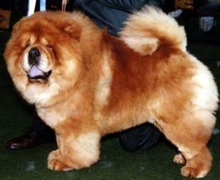
World Winner  -1997,  European  Winner -1997,  1999 | Red female  ALKMENA  KAINA | MI PAO'S MIDNIGHT  CRUISING ex ALKMENA DREAM BONIFACIA, breeder and owner.  A.Burykin  http://chow.chow.ru/alkmena  _kaina.shtml | 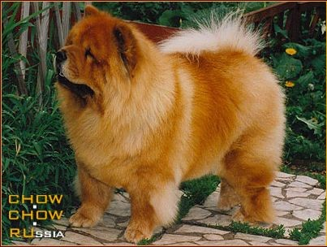
World Winner - 1998 | Red male ILLARION | MAFUSAIL INSANTA ex  YASEN’, breeder I.Burtseva  owner N.Chikov  http://ingrus.net/chow-chow/ details.php?id=4591

Junior World  Winner -1998 | Red male  BIS​ ​LAC  ABSOLUTE | DESSERT STORM OF THE  ROYAL CLUB ex BIS LAC DESSA,  breeder N. Feofanova, owners E.Gavrushina and  Fesenko  http://ingrus.net/chow-chow/ details.php?id=45 | 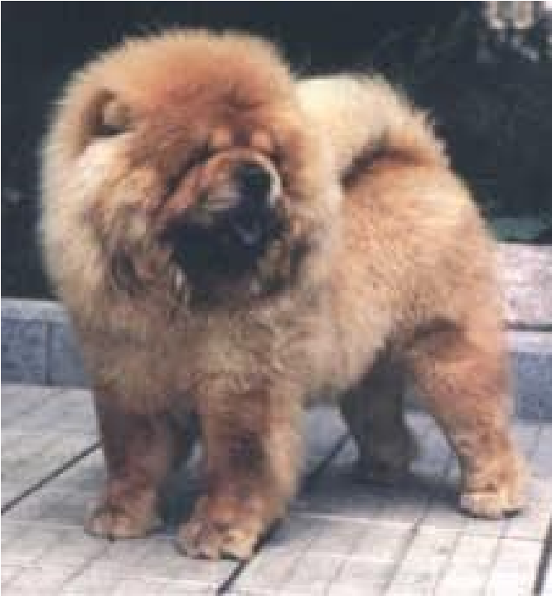
European  Winner -2000 | Cream male  ALKMENA  ORFI | MI-PAO'S CREAM  FROSTING ex MI-PAO'S FLIGHT OF FANCY, breeder and owner:  A.Burykin  http://ingrus.net/chow-chow/ details.php?id=50 | 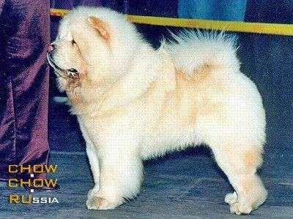
World Winner - 2003 | Black female  RAVJU SIMONA | ZOLOTAYA ORKHIDEYA  GRAND CARDINAL ex RAVJU BELADONNA,  breeder and owner: V.Rakuta  http://chow.chow.ru/ravju-si mona.shtml | 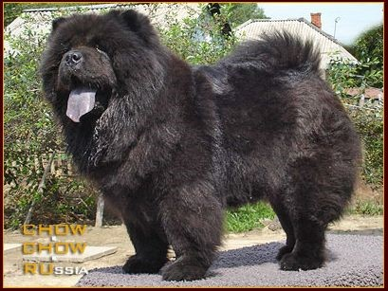

Junior World  Winner -2003 | Red male  BON TRIUMPH  ALEX | MAI-ANNS SHORT  CIRCUIT ex ANITA EXCLUSIVE,  breeder and owner:  M.Verovischeva  http://ingrus.net/chow-chow/ details.php?id=1274 | 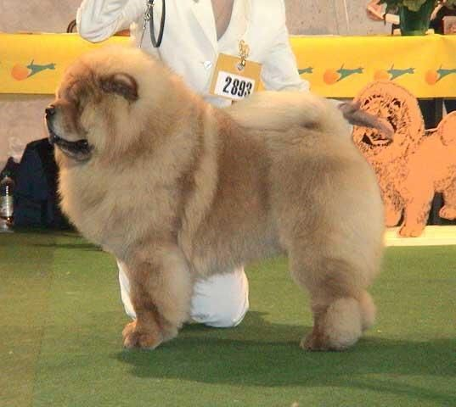
European  Winner -2003 | Black female  YUNONA | PONDVIEW*S BLACK RUSSION ex YURMA, breeder: L.Cherepanova  owner: E. Suschenko  http://ingrus.net/chow-chow/ details.php?id=948 | 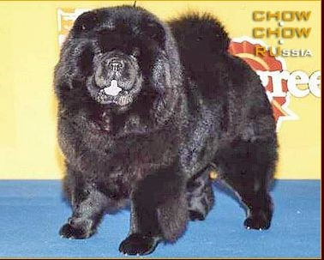
World Winner - 2006 | Black male  BON TRIUMPH  DARIY BLACK  KING | DARK SIDE OF THE  MOON DEI LEONI IMPERIALI ex  ANITA EXCLUSIVE breeder and owner:  M.Verovischeva  http://ingrus.net/chow-chow/ details.php?id=109 | 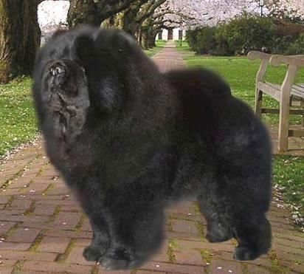

Junior World  Winner - 2006,  ВОВ Craft  -2006 | Black female  BON  TRIUMPH  OTRADA | BON TRIUMPH DARIY  BLACK KING ex BON TRIUMPH BIZHU  breeder and owner:  M.Verovischeva  http://www.bontriumph.ru/bit ch/OtradaR.htm | 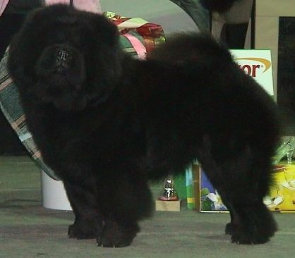
World Winner - 2008, 2009 | Black female  BAGIRA S  ZOLOTOGO  PRIISKA | LO-RE' PEPPERLAND  PIANO MAN ex IRISKA OT  ALISKI  breeder: V. Kornilov  owner: E. Petrova  http://ingrus.net/chow-chow/ details.php?id=11222 | 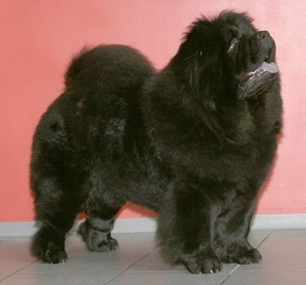
World Winner - 2009, 2011 | Red male  BON TRIUMPH  SHANS | FEARLESS HEART IMAGE  CREAM KING ex  BON TRIUMPH ZEFIRKA breeder and owner:  M.Verovischeva  http://chow.chow.ru/bon_triu mph_shans.shtml | 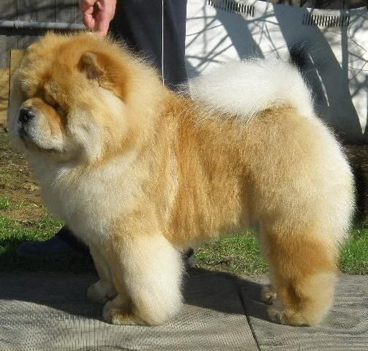

Junior World  Winner -2010 | Black male  GRAND  BOUBOU  BARRYMORE | CROSS B'S IT'S A  CHANCE YA TAKE ex  BAGIRA S ZOLOTOGO  PRIISKA  breeder and owner: E.Petrova  http://ingrus.net/chow-chow/  details.php?id=14615 | 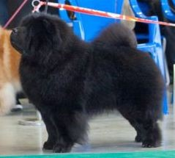
Junior  European  Winner -2010 | Black male  HONILAND  EXCLUSIVE  BLACK  SMOOTH | PARAMOUNT STYLISH  SMOOTH ex HONILAND GRAND PRIX  breeder and owner: E.  Shorina  http://chow.chow.ru/honiland _exclusive_black_smooth.sht ml | 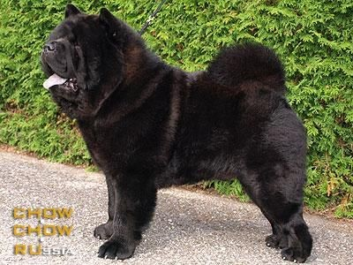
Junior  European  Winner - 2010 | Red male  HONILAND  TRAVEL TO GLORY | CASSANOVA THE  DISCOVERY ex  HONILAND GRAND PRIX breeder: E. Shorina  owner: I.Svetlichnaya  http://irinschow.ru/p17.htm | 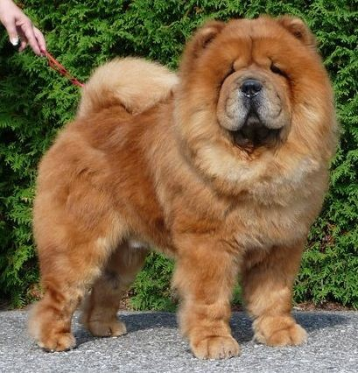

European  Winner - 2010 | Red female FAY SIN  YESHEE  MAIHOA | FAY SIN NYAO SHON LING ex ATTIKA MEY breeder and owner:  N.Revenko  http://ingrus.net/chow-chow/ details.php?id=17440 | 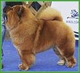
Junior World Winner - 2011 | Black male  BON TRIUMPH LORD BLACK | ORINELL'S EMBRACE ME ex GIVANCHY FOR BON  TRIUMPH STYLE OF MARY  breeder and owner:  M.Verovischeva  http://ingrus.net/chow-chow/ details.php?id=18252 | 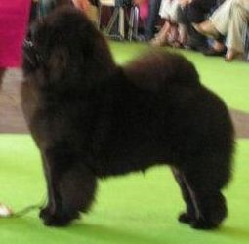
World Winner  - 2012, 2013 | Black male  BON TRIUMPH  JACK | KAMA LAKSHMI  KAZANOVA ex​  CLEOPATRA DE LOS PERROS DE BIGO breeder and owner:  M.Verovischeva  http://ingrus.net/chow-chow/ details.php?id=11384 | 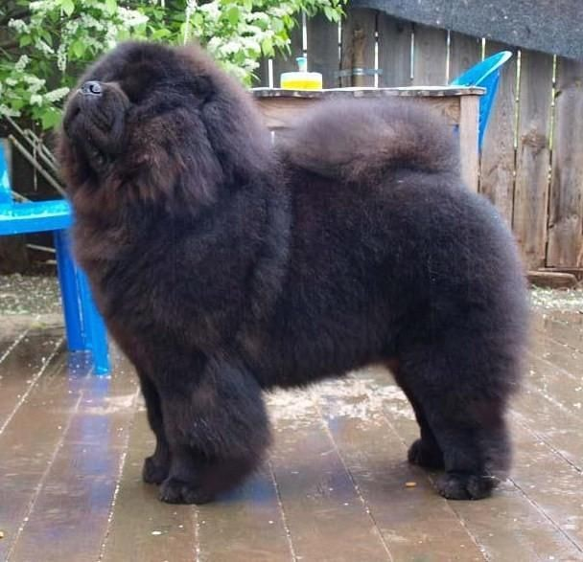

Veteran World Winner - 2012 | Red male  BABOO BANDI | TSVETOK EL’FOV  JELEZNYI FELIX ex  PAULA  breeder: A.Proskurina  owner: Yu.Vinogradova  http://banvinfun.ru/baboo_ba ndy | 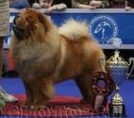
European  Winner - 2012,  World Winner  - 2013,  Veteran World Winner - 2016 | Cream female  CHUDO SVETA  DRAGON FLAY | PRINTS DATSKII IZ  SVYATOGO GRAALYA ex MIZANFA ZHOLI​  HAPPY ELZI LUNNY SVET  b​reeder and owner:  L.Dubisskaya  http://ingrus.net/chow-chow/ details.php?id=28769 | 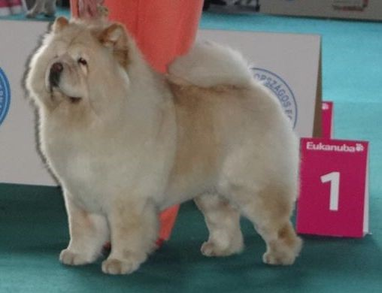
Cruft - 2013,  ЛК | Cream male  BON TRIUMPH  ROLEX | ORINELL'S EMBRACE ME ex FEARLESS HEART CREAM BRULE  breeder and owner:  M.Verovischeva  http://ingrus.net/chow-chow/  details.php?id=18231 | 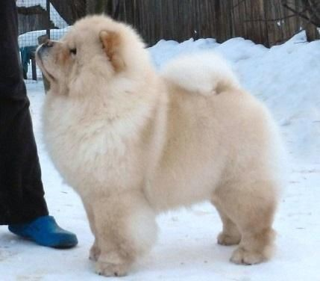

World Winner - 2014 | Cream female  FEARLESS  HEART CREAM  BRULE | BON TRIUMPH SUGAR  WHITE​ ex FEARLESS​  HEART INFANTA  CREAM DREAM  Breeder: I.Zinovieva  owner: M.Verovischeva  http://ingrus.net/chow-chow/ details.php?id=3458 | 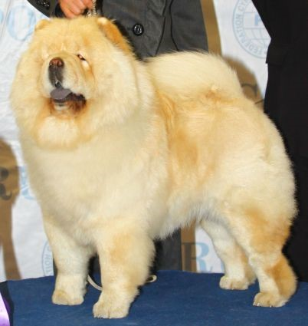
Cruft's 2014,  ВОВ | Cream female  BON TRIUMPH  TIFFANY | BON TRIUMPH JACK​ ex  BON TRIUMPH  ZEFIRKA​ breeder and​  owner: M.Verovischeva  http://ingrus.net/chow-chow/ details.php?id=18235 | 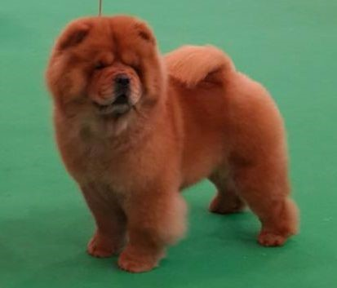
Cruft's 2014,  ЛК | Black male  SIMAUTA DESS  LOGRIS | ZORRO LIETUVOS  LIUTAS ex PIUK CHOW  ROSE PRINCESS OF DENMARK  breeder and owner:  A.Elyutina  http://ingrus.net/chow-chow/  details.php?id=15529 | 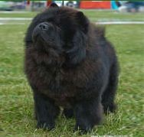
World Winner - 2015 | Black female  REX DEUS  GERMIONA | AGAT REX DEUS ex  ALKMENA EKO ONO  breeder and owner: Yu.  Akhmedchina  http://ingrus.net/chow-chow/ details.php?id=30334 | 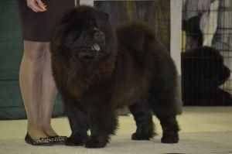
Junior World Winner - 2016 | Red, male  REKS DEUS EMIREYTS | AGAT REX DEUS ex  ALKMENA EKO ONO breeder and owner:  Yu. Akhmedchina  http://ingrus.net/chow-chow/ details.php?id=27801 | 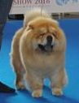
World Winner - 2016 | Red female  DGULIDEIL  BRAVO-BRAVI  SSIMO | Сука, рыжая,  CH-DALEN DARKI  GOLDEN MAN х  DGULIDEIL YADRJENA  MATRJENA  зав./вл J. Khutoryanskaya,​ http://www.djulideil.com/bitc  hes/bravo_bravissimo_e.shtm l | 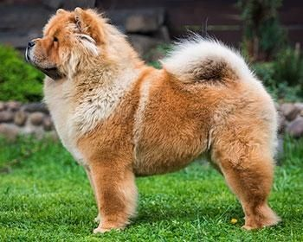

References

- Наталья Феофанова, Татьяна Абакумова «Чау-Чау в России» http://www.chow-chow.cc/legend/rushi5_m.htm
- Кто есть Кто в мире чау-чау http://www.chow-chow.cc/books/who02_m.htm
- М.Ковешникова, А.Елютина, Н.Ташева, Л.Ильина, Л.Шевченко «ИСТОРИЯ РАЗВЕДЕНИЯ ЧАУ-ЧАУ» http://www.chow-chow.cc/legend/rushi2_m.htm
- Братья наши меньшие http://club443.ru/index.php?showtopic=148662&st=120
- Базы данных Чау-Чау:
​http://www.chowswho.com/​ ;
​http://chow.chow.ru/​ ;
​http://ingrus.net/chow-chow/
- Интервью А. Бурыкина (питомник Алкмена) 2000 год http://chow-russia.livejournal.com/4770.html
- Т. Абакумовой, «Чау-чау пришелец с Востока»,
- 10 лет чау-чау в РОССИИ ​Елютина Алена, г.Москва, питомник чау-чау "Симаута Десс" http://www.chow-chow.cc/news/66_chavka_news_elutina10years.htm
- Чау-Чау. Чемпионы Мира 1937-2004 http://www.chow-chow.cc/chemp/chempi_world.htm
- Победители Крафта породы Чау-Чау ​http://www.northeasternchowchowclub.com/crufts.htm
- Питомники Чау Европы http://www.eurobreeder.com/breeds/chow_chow.html
- Чемпионы чау-чау России
http://chowchowplus.borda.ru/?1-4-0-00000142-000-0-0-1298188269

